Title in ENGLISH, please use the style “TITLE_PAPER”
Subtitle in ENGLISH, please use the style “SUBTITLE_PAPER”

First Name Author Last Name Author 1,*, First Name Author Last Name Author 2, please use the style “AUTHOR”

1 Dipartimento di Design, Università degli Studi di …, Indirizzo per esteso. Si prega di usare lo stile “AFFIL”.
2 Dipartimento di Design, Università degli Studi di …, Indirizzo per esteso.
* nome.cognome@università.it (solo del corresponding author) please use the style “AFFIL”

ABSTRACT IN ENGLISH: Abstract length of no more than 150 words. Please use the style “ABSTR”. Lorem ipsum dolor sit amet, consectetur adipiscing elit. Proin turpis dolor, mattis et interdum et, blandit ut justo. Vestibulum tincidunt viverra orci, et ultrices dolor vestibulum ut. Aliquam iaculis, elit aliquam ultrices feugiat, ante dui vulputate metus, vitae dapibus nulla ipsum vel odio. In fringilla lorem eu nisi sollicitudin varius aliquam at magna. Fusce ipsum quam, placerat ac ultrices ac, pulvinar nec libero. Quisque feugiat neque eu nisl rutrum, semper dictum metus commodo.
Keywords in ENGLISH (a minimum of 3 and a maximum of 5)

TITLE 1 (use the style “Titolo 1”)
Body of text, please use the style “PARAGRAPH”. Length of contribution between 5000 words and 8000 words. The form of each individual contribution should be set up as a technical-scientific essay. The text should allow for:
- Argue scientifically, from the research, its relation to the contents of the call, specifically the session in which you participated.
- Outline the methods you intend to adopt and the results to be obtained/under development, and indicate how you plan to generalise them in favour of the scientific community.
- Indicate which considerations can be generalised in favour of knowledge growth in the fields of health, technology and human factors.
Bold and italics are not recommended in the body of the text.
Images: minimum 3 maximum 5 including captions and their indication in the text

TITLE 2 (use the style “Titolo 2”, for first and subsequent returns)
Body of text, please use the style “PARAGRAPH”. Lorem ipsum dolor sit amet, consectetur adipiscing elit. Proin turpis dolor, mattis et interdum et, blandit ut justo. Vestibulum tincidunt viverra orci, et ultrices dolor vestibulum ut. Aliquam iaculis, elit aliquam ultrices feugiat, ante dui vulputate metus, vitae dapibus nulla ipsum vel odio. In fringilla lorem eu nisi sollicitudin varius aliquam at magna. Fusce ipsum quam, placerat ac ultrices ac, pulvinar nec libero. Quisque feugiat neque eu nisl rutrum, semper dictum metus commodo.

Bibliography
Please enter bibliographical sources in the body of the text as (Surname, 2000).
Please enter the references in the Bibliography in alphabetical order (follow the APA template available here: https://apastyle.apa.org/instructional-aids/reference-examples.pdf
Please use the style “REFERENCES” when writing.

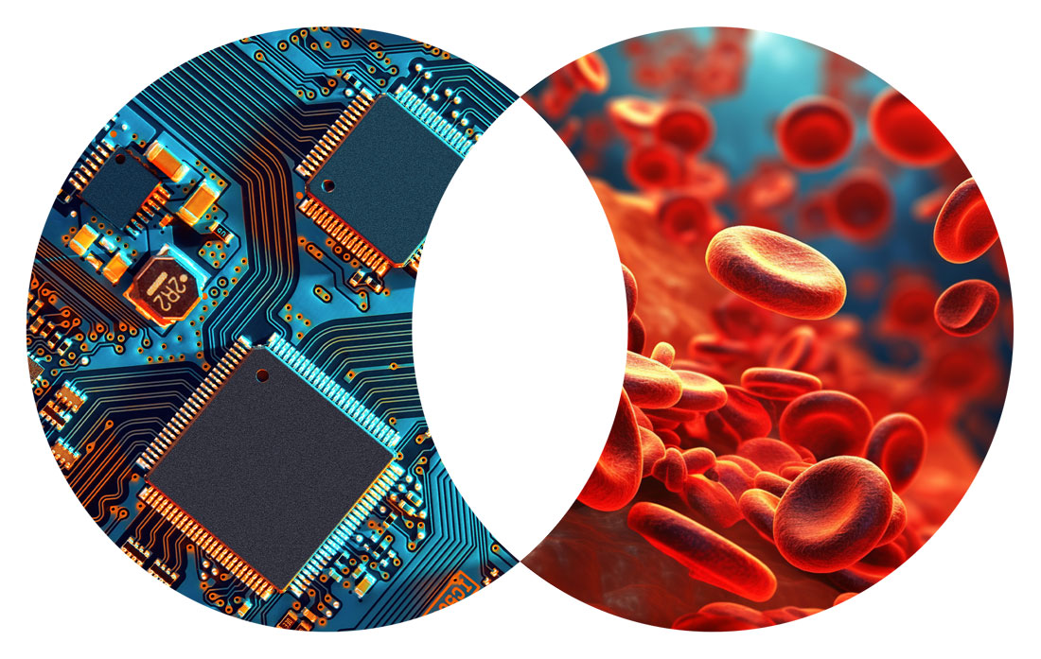
Insert figures and tables on a new page at the end of the paper

Fig. 1. Image title, please use the style “FIGURE”. 300 PPI resolution images are recommended, to be attached in this template and sent as an email attachment for editorial post-production.

Tab. 1. Table title, please use the style “FIGURE”. For the text in the table, please use the style “TABLE”
Column 1 | Column 2 | Column 3 | Column 4
Text 1.1. | Text 2.1. | Text 3.1. | Text 4.1.
Text 1.2. | Text 2.2. | Text 3.2. | Text 4.2.

Please submit your project to

If necessary, please insert footnotes. Please use the style “FOOTNOTE”

